 | 10.1.14 Editors - Compositor Editor - Header - Add Menu - Utilities
Table of content
Detailed table of content 1
Add menu - Utilities 2
Map Range 3
Map Value 3
Math 4
Normalize 5
Levels 5
Split 6
Switch 7
Switch View 7

Detailed table of content
Detailed table of content
Detailed table of content 1
Add menu - Utilities 2
Map Range 3
Usage 3
Inputs 3
Value 3
From Min/Max 3
To Min/Max 3
Properties 3
Clamp 3
Outputs 3
Value 3
Map Value 3
Inputs 3
Value 3
Properties 4
Offset 4
Size 4
Use Minimum, Maximum 4
Min, Max 4
Outputs 4
Value 4
Math 4
Inputs 4
Value 4
Value 4
Properties 4
Operation 4
Clamp 5
Outputs 5
Value 5
Normalize 5
Inputs 5
Value 5
Outputs 5
Value 5
Levels 5
Inputs 5
Image 5
Properties 5
Channel 5
Outputs 6
Mean 6
Std Dev (Standard deviation) 6
Split 6
Inputs 6
Image 6
Image 6
Properties 6
Axis 6
Factor 6
Outputs 6
Image 6
Switch 7
Properties 7
Switch 7
Inputs 7
Off 7
On 7
Image 7
Switch View 7
Inputs 7
Left 7
Right 7
Outputs 7
Image 7

Add menu - Utilities
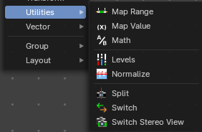
Here you find nodes that are used as utilities.

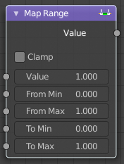
Map Range
This node allows to convert (map) an input value range into a destination range. By default, values outside the specified input range will be proportionally mapped as well. This node is similar to Map Value node but provides a more intuitive way to specify the desired output range.

Usage
One important use case is to easily map the original range of the Z-depth channel to a more usable range (i.e: 0.0 - 1.0) for use as a matte for colorization or filtering operations.

Inputs

Value
Standard value input.

From Min/Max
Start/End of the input value range.

To Min/Max
Start/End of the destination range.

Properties

Clamp
Clamps values to Min/Max of the destination range.

Outputs

Value
Standard value output.

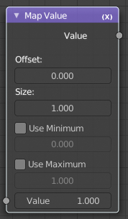
Map Value
Map Value node is used to scale, offset and clamp values.

Inputs

Value
Standard Value input. (Value refers to each vector in the set.)

Properties

Offset
Factor added to the input value.

Size
Scales (multiply) the input value.

Use Minimum, Maximum
Enable this to activate their related operation.

Min, Max
Defines a range between minimum and maximum to clamp the input value to.

Outputs

Value
Standard value output.

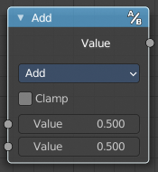
Math
The Math Node performs math operations.

Inputs

Value
First numerical value. The trigonometric functions accept values in radians.

Value
Second numerical value. This value is not used in functions that accept only one parameter like the trigonometric functions, Round and Absolute.

Properties

Operation
Here you can choose what mathematical operation to perform.
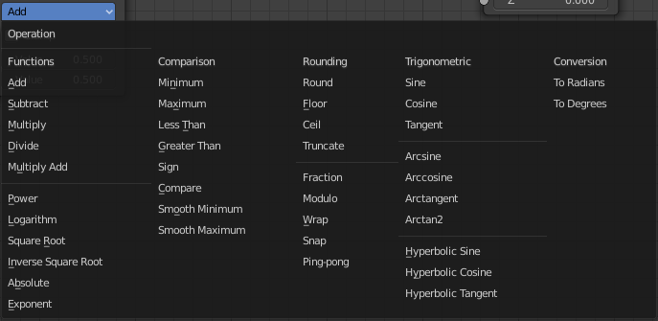

Clamp
Limits the output to the range (0 to 1). See clamp.

Outputs

Value
Numerical value output.

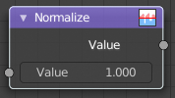
Normalize
Find the minimum and maximum values of a single channel. Then map the values to a range of 0 and 1.

Inputs

Value
Standard value input.

Outputs

Value
Standard value output.

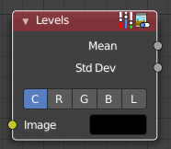
Levels
The Levels Node read the inputs color channels and outputs analytical values.

Inputs

Image
The image input.

Properties

Channel
The channels. C (Combined RGB), R (Red), G (Green), B (Blue), L (Luminance)

Outputs
1D values based on the levels of an image.

Mean
The mean is the average value of all image pixels in specified channel (combined, red, green, blue, luminance). It tells you how dark or bright the image is and can be used as such for setups that depend on how is input “bright” or “dark”.

Std Dev (Standard deviation)
How much those pixel values differ from the mean. A low standard deviation indicates that the pixel values tend to be very close to the mean. A high standard deviation indicates that the values are spread out over a large range of values.
The visualization of such data is just a gray rectangle.

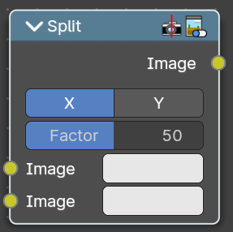
Split
Allows to combine two images horizontally or vertically

Inputs

Image
The first image.

Image
The second image.

Properties

Axis
If to split the image horizontally or vertically.

Factor
How much percent the first image or the second image is visible.

Outputs

Image
Image output.

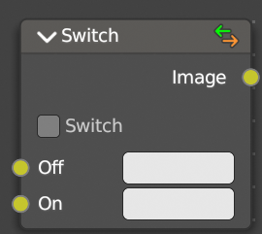
Switch
The Switch node is akin to a boolean, where you can use a toggle to choose what is shown with on or off.

Properties

Switch
The toggle that turns the switch on or off resulting in the final output being whatever is in the on or off input.

Inputs

Off
The image that is shown when the toggle is off.

On
The image that is shown when the toggle is on.

Image
Standard RGB image output.

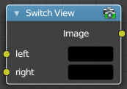
Switch View
The Switch View node combines the views (left and right) into a single Stereo 3D output. This can be useful if for example, you need to treat the view as separate images by combining each of the views.

Inputs

Left
Left-eye image input.

Right
Right-eye image input.

Outputs

Image
Stereo 3D image output.

